72.07.00
To [George Bentham]
RBG Kew, Kew correspondence, Australia, Mueller, 1858-70, f. 40.

Sketch of Doryanthes Hartmanni, copied from a pencil drawing of Mr Hartmann; who discovered this noble plant on rocky cataracts beyond Towomba, Queensland.
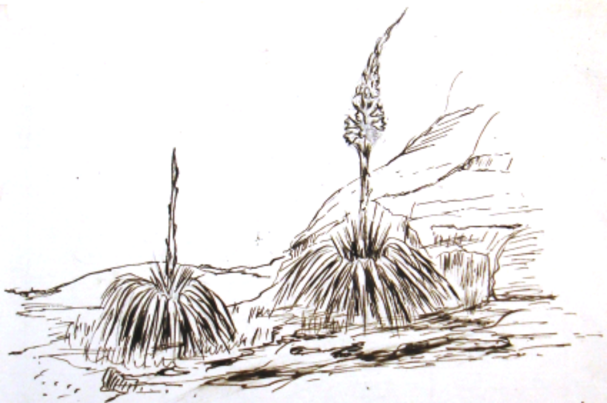

The spicate inflorescence is very different to that of D. excelsa. How far it agrees with D. Palmeri of Hill I cannot say, as I never saw flowers of D. Hartmanni and never any other parts of D. Palmeri than one single flower, which is smaller than that of D. excelsa.

Doryanthes excelsa
Doryanthes Hartmanni
Doryanthes Palmeri

Bentham is the most likely recipient, as he had not at this stage commenced working on the Australian Amaryllideae (see G. Bentham to M, 19 November 1872). The earliest probable date of the note is July 1872; see C. Hartmann to M, 28 June 1872, in which finding the species was described.
This name has not been found in published sources (APNI, accessed 16 November 2020). Bentham (1863-78), vol. 6, pp. 452-3, includes a specimen from Hartmann under D. palmeri, but from 'Mackenzie River' which is inland from Rockhampton, Qld, not near Toowoomba.
Toowoomba, Qld.
The original image is 128 mm wide by 89mm deep: 72-07-00_image01.jpg.

